Data in MongoDB has a flexible schema.documents in the same collection. They do not need to have the same set of fields or structure, and common fields in a collection’s documents may hold different types of data.

Some considerations while designing Schema in MongoDB
- Design your schema according to user requirements.
- Combine objects into one document if you will use them together. Otherwise separate them (but make sure there should not be need of joins).
- Duplicate the data (but limited) because disk space is cheap as compare to compute time.
- Do joins while write, not on read.
- Optimize your schema for most frequent use cases.
- Do complex aggregation in the schema.

Example
Suppose a client needs a database design for his blog/website and see the differences between RDBMS and MongoDB schema design. Website has the following requirements.
- Every post has the unique title, description and url.
- Every post can have one or more tags.
- Every post has the name of its publisher and total number of likes.
- Every post has comments given by users along with their name, message, data-time and likes.
- On each post, there can be zero or more comments.
In RDBMS schema, design for above requirements will have minimum three tables.

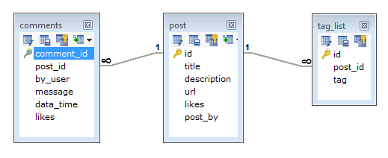

While in MongoDB schema, design will have one collection post and the following structure −
{
_id: POST_ID
title: TITLE_OF_POST,
description: POST_DESCRIPTION,
by: POST_BY,
url: URL_OF_POST,
tags: [TAG1, TAG2, TAG3],
likes: TOTAL_LIKES,
comments: [
{
user:'COMMENT_BY',
message: TEXT,
dateCreated: DATE_TIME,
like: LIKES
},
{
user:'COMMENT_BY',
message: TEXT,
dateCreated: DATE_TIME,
like: LIKES
}
]
}
So while showing the data, in RDBMS you need to join three tables and in MongoDB, data will be shown from one collection only.

https://docs.mongodb.com/manual/core/data-modeling-introduction/

References
In general, use normalized data models:
- when embedding would result in duplication of data but would not provide sufficient read performance advantages to outweigh the implications of the duplication.
- to represent more complex many-to-many relationships.
- to model large hierarchical data sets.
References provides more flexibility than embedding. However, client-side applications must issue follow-up queries to resolve the references. In other words, normalized data models can require more round trips to the server.

Embed
These schema are generally known as “denormalized” models
Applications may need to issue fewer queries and updates to complete common operations.
In general, use embedded data models when:
- you have “contains” relationships between entities. See Model One-to-One Relationships with Embedded Documents.
- you have one-to-many relationships between entities. In these relationships the “many” or child documents always appear with or are viewed in the context of the “one” or parent documents. See Model One-to-Many Relationships with Embedded Documents.
In general, embedding provides better performance for read operations, as well as the ability to request and retrieve related data in a single database operation. Embedded data models make it possible to update related data in a single atomic write operation.
However, embedding related data in documents may lead to situations where documents grow after creation. With the MMAPv1 storage engine, document growth can impact write performance and lead to data fragmentatio

https://docs.mongodb.com/manual/core/data-model-design/

Atomicity of Write Operations
In MongoDB, write operations are atomic at the document level, and no single write operation can atomically affect more than one document or more than one collection. A denormalized data model with embedded data combines all related data for a represented entity in a single document. This facilitates atomic write operations since a single write operation can insert or update the data for an entity. Normalizing the data would split the data across multiple collections and would require multiple write operations that are not atomic collectively.

